**РОЗГОРНУТИ ПРОГРАМНЕ ОТОЧЕННЯ ДЛЯ РОБОТИ З БД**

**1) Встановити** [**SQL Server Management Studio**](https://learn.microsoft.com/en-us/sql/ssms/download-sql-server-management-studio-ssms?view=sql-server-ver16)

<https://learn.microsoft.com/en-us/sql/ssms/download-sql-server-management-studio-ssms?view=sql-server-ver16>

**2) Встановити SQL Server // Free edition // Express**

SQL Server 2022 Express is a free edition of SQL Server, ideal for development and production for desktop, web, and small server applications.

<https://www.microsoft.com/en-us/sql-server/sql-server-downloads>

**3) Зареєструватись на** <https://github.com/>

**4) Встановити Git**

<https://git-scm.com/download/win>

5) **Встановити GitHub Desktop** <https://desktop.github.com/>

**РОЗГОРНУТИ УЧБОВУ БАЗУ ДАНИХ**

**Створюємо нову базу даних**

1) В SQL Server Management Studio на панелі інструментів натиснути кнопку «New Query»

2) У вікні, що відкрилось написати наступний запит SQL:

CREATE DATABASE WebStor;

Виділити його та натиснути на кнопку «Execute»

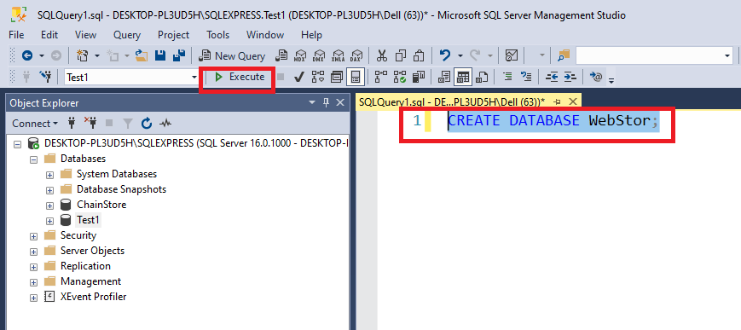

3) Оновіть «Оглядач об'єктів» та переконайтесь, що нова база даних відображається в ньому:

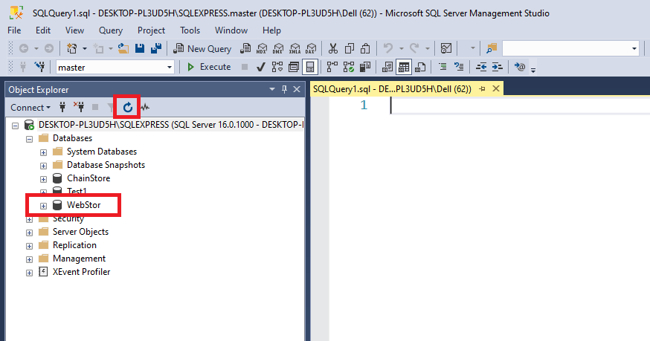

**Створюємо таблиці в базі даних WebStor**

1) В SQL Server Management Studio на панелі інструментів натиснути кнопку «New Query»

2) Переключитись на БД WebStor

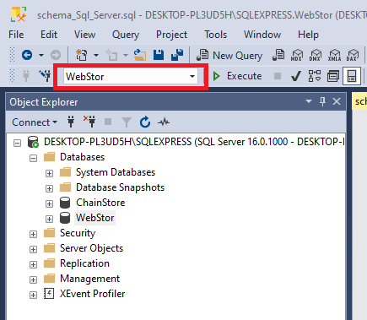

3) Скопіювати та вставити у вікно запитів наступний код. Виділити його та виконати, натиснувши кнопку «Execute»:

CREATE TABLE PRODUCTS

(MFR_ID CHAR(3) NOT NULL,

PRODUCT_ID CHAR(5) NOT NULL,

DESCRIPTION VARCHAR(20) NOT NULL,

PRICE MONEY NOT NULL,

QTY_ON_HAND INTEGER NOT NULL,

PRIMARY KEY (MFR_ID, PRODUCT_ID))

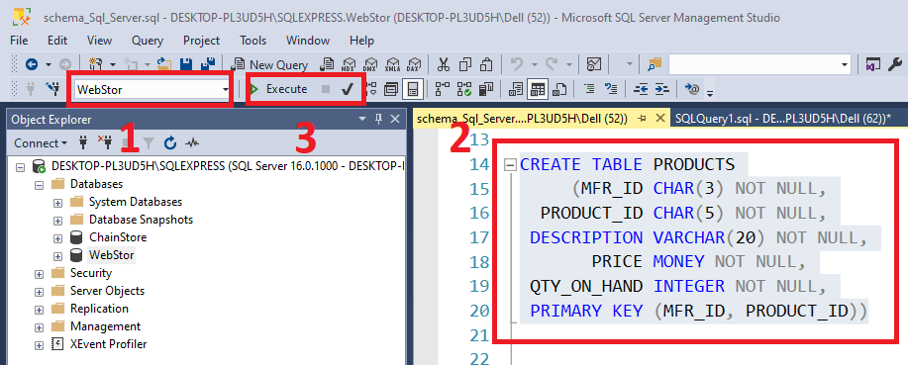

Після виконання кожного запиту в полі Messages повинно відображатись сповіщення про вдале виконання запиту: Commands completed successfully.

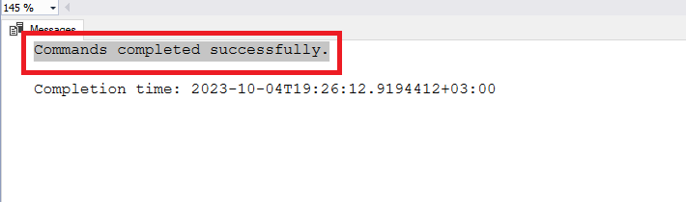

Аналогічним чином, послідовно, як написано в поточному пункті 3 зробити з наступними пронумерованими фрагментами SQL запитів. Для кожного окремого фрагменту виконувати три, описані вище, кроки. Все можна робити в одному вікні запитів, поступово копіюючи та вставляючи необхідні фрагменти.

Фрагмент 2

CREATE TABLE OFFICES

(OFFICE INTEGER NOT NULL,

CITY VARCHAR(15) NOT NULL,

REGION VARCHAR(10) NOT NULL,

MGR INTEGER,

TARGET MONEY,

SALES MONEY NOT NULL,

PRIMARY KEY (OFFICE))

Фрагмент 3

CREATE TABLE SALESREPS

(EMPL_NUM INTEGER NOT NULL,

CHECK (EMPL_NUM BETWEEN 101 AND 199),

NAME VARCHAR(15) NOT NULL,

AGE INTEGER,

REP_OFFICE INTEGER,

TITLE VARCHAR(10),

HIRE_DATE DATETIME NOT NULL,

MANAGER INTEGER,

QUOTA MONEY,

SALES MONEY NOT NULL,

PRIMARY KEY (EMPL_NUM),

FOREIGN KEY (MANAGER)

REFERENCES SALESREPS

ON DELETE NO ACTION,

CONSTRAINT WORKSIN FOREIGN KEY (REP_OFFICE)

REFERENCES OFFICES

ON DELETE SET NULL)

Фрагмент 4

CREATE TABLE CUSTOMERS

(CUST_NUM INTEGER NOT NULL,

COMPANY VARCHAR(20) NOT NULL,

CUST_REP INTEGER,

CREDIT_LIMIT MONEY,

PRIMARY KEY (CUST_NUM),

CONSTRAINT HASREP FOREIGN KEY (CUST_REP)

REFERENCES SALESREPS

ON DELETE SET NULL)

Фрагмент 5

CREATE TABLE ORDERS

(ORDER_NUM INTEGER NOT NULL,

CHECK (ORDER_NUM > 100000),

ORDER_DATE DATETIME NOT NULL,

CUST INTEGER NOT NULL,

REP INTEGER,

MFR CHAR(3) NOT NULL,

PRODUCT CHAR(5) NOT NULL,

QTY INTEGER NOT NULL,

AMOUNT MONEY NOT NULL,

PRIMARY KEY (ORDER_NUM),

CONSTRAINT PLACEDBY FOREIGN KEY (CUST)

REFERENCES CUSTOMERS

ON DELETE CASCADE,

CONSTRAINT TAKENBY FOREIGN KEY (REP)

REFERENCES SALESREPS

ON DELETE SET NULL,

CONSTRAINT ISFOR FOREIGN KEY (MFR, PRODUCT)

REFERENCES PRODUCTS)

go

Фрагмент 6

ALTER TABLE OFFICES

ADD CONSTRAINT HASMGR

FOREIGN KEY (MGR) REFERENCES SALESREPS(EMPL_NUM)

ON DELETE SET NULL

Go

4) Переконатись, що необхідні таблиці створені в БД:

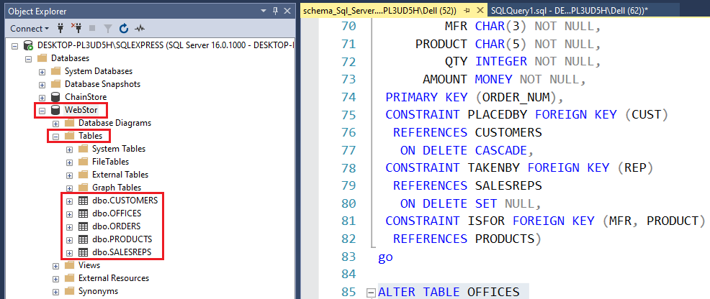

**Заповнюємо таблиці даними**

1) В SQL Server Management Studio на панелі інструментів натиснути кнопку «New Query»

2) У вікні, що відкрилось написати наступний запит SQL, виділити його та виконати:

USE WebStor;

go

delete from orders;

delete from customers;

update offices set mgr=null;

delete from salesreps;

delete from offices;

delete from products;

go

---

--- PRODUCTS

---

INSERT INTO PRODUCTS VALUES('REI','2A45C','Ratchet Link',79.00,210);

INSERT INTO PRODUCTS VALUES('ACI','4100Y','Widget Remover',2750.00,25);

INSERT INTO PRODUCTS VALUES('QSA','XK47 ','Reducer',355.00,38);

INSERT INTO PRODUCTS VALUES('BIC','41627','Plate',180.00,0);

INSERT INTO PRODUCTS VALUES('IMM','779C ','900-LB Brace',1875.00,9);

INSERT INTO PRODUCTS VALUES('ACI','41003','Size 3 Widget',107.00,207);

INSERT INTO PRODUCTS VALUES('ACI','41004','Size 4 Widget',117.00,139);

INSERT INTO PRODUCTS VALUES('BIC','41003','Handle',652.00,3);

INSERT INTO PRODUCTS VALUES('IMM','887P ','Brace Pin',250.00,24);

INSERT INTO PRODUCTS VALUES('QSA','XK48 ','Reducer',134.00,203);

INSERT INTO PRODUCTS VALUES('REI','2A44L','Left Hinge',4500.00,12);

INSERT INTO PRODUCTS VALUES('FEA','112 ','Housing',148.00,115);

INSERT INTO PRODUCTS VALUES('IMM','887H ','Brace Holder',54.00,223);

INSERT INTO PRODUCTS VALUES('BIC','41089','Retainer',225.00,78);

INSERT INTO PRODUCTS VALUES('ACI','41001','Size 1 Wiget',55.00,277);

INSERT INTO PRODUCTS VALUES('IMM','775C ','500-lb Brace',1425.00,5);

INSERT INTO PRODUCTS VALUES('ACI','4100Z','Widget Installer',2500.00,28);

INSERT INTO PRODUCTS VALUES('QSA','XK48A','Reducer',177.00,37);

INSERT INTO PRODUCTS VALUES('ACI','41002','Size 2 Widget',76.00,167);

INSERT INTO PRODUCTS VALUES('REI','2A44R','Right Hinge',4500.00,12);

INSERT INTO PRODUCTS VALUES('IMM','773C ','300-lb Brace',975.00,28);

INSERT INTO PRODUCTS VALUES('ACI','4100X','Widget Adjuster',25.00,37);

INSERT INTO PRODUCTS VALUES('FEA','114 ','Motor Mount',243.00,15);

INSERT INTO PRODUCTS VALUES('IMM','887X ','Brace Retainer',475.00,32);

INSERT INTO PRODUCTS VALUES('REI','2A44G','Hinge Pin',350.00,14);

go

---

--- OFFICES

---

INSERT INTO OFFICES VALUES(22,'Denver','Western',null,300000.00,186042.00);

INSERT INTO OFFICES VALUES(11,'New York','Eastern',null,575000.00,692637.00);

INSERT INTO OFFICES VALUES(12,'Chicago','Eastern',null,800000.00,735042.00);

INSERT INTO OFFICES VALUES(13,'Atlanta','Eastern',null,350000.00,367911.00);

INSERT INTO OFFICES VALUES(21,'Los Angeles','Western',null,725000.00,835915.00);

go

---

--- SALESREPS

---

INSERT INTO SALESREPS VALUES (106,'Sam Clark',52,11,'VP Sales','2006-06-14',null,275000.00,299912.00);

INSERT INTO SALESREPS VALUES (109,'Mary Jones',31,11,'Sales Rep','2007-10-12',106,300000.00,392725.00);

INSERT INTO SALESREPS VALUES (104,'Bob Smith',33,12,'Sales Mgr','2005-05-19',106,200000.00,142594.00);

INSERT INTO SALESREPS VALUES (108,'Larry Fitch',62,21,'Sales Mgr','2007-10-12',106,350000.00,361865.00);

INSERT INTO SALESREPS VALUES (105,'Bill Adams',37,13,'Sales Rep','2006-02-12',104,350000.00,367911.00);

INSERT INTO SALESREPS VALUES (102,'Sue Smith',48,21,'Sales Rep','2004-12-10',108,350000.00,474050.00);

INSERT INTO SALESREPS VALUES (101,'Dan Roberts',45,12,'Sales Rep','2004-10-20',104,300000.00,305673.00);

INSERT INTO SALESREPS VALUES (110,'Tom Snyder',41,null,'Sales Rep','2008-01-13',101,null,75985.00);

INSERT INTO SALESREPS VALUES (103,'Paul Cruz',29,12,'Sales Rep','2005-03-01',104,275000.00,286775.00);

INSERT INTO SALESREPS VALUES (107,'Nancy Angelli',49,22,'Sales Rep','2006-11-14',108,300000.00,186042.00);

go

---

--- OFFICE MANAGERS

---

UPDATE OFFICES SET MGR=108 WHERE OFFICE=22;

UPDATE OFFICES SET MGR=106 WHERE OFFICE=11;

UPDATE OFFICES SET MGR=104 WHERE OFFICE=12;

UPDATE OFFICES SET MGR=105 WHERE OFFICE=13;

UPDATE OFFICES SET MGR=108 WHERE OFFICE=21;

go

---

--- CUSTOMERS

---

INSERT INTO CUSTOMERS VALUES(2111,'JCP Inc.',103,50000.00);

INSERT INTO CUSTOMERS VALUES(2102,'First Corp.',101,65000.00);

INSERT INTO CUSTOMERS VALUES(2103,'Acme Mfg.',105,50000.00);

INSERT INTO CUSTOMERS VALUES(2123,'Carter & Sons',102,40000.00);

INSERT INTO CUSTOMERS VALUES(2107,'Ace International',110,35000.00);

INSERT INTO CUSTOMERS VALUES(2115,'Smithson Corp.',101,20000.00);

INSERT INTO CUSTOMERS VALUES(2101,'Jones Mfg.',106,65000.00);

INSERT INTO CUSTOMERS VALUES(2112,'Zetacorp',108,50000.00);

INSERT INTO CUSTOMERS VALUES(2121,'QMA Assoc.',103,45000.00);

INSERT INTO CUSTOMERS VALUES(2114,'Orion Corp.',102,20000.00);

INSERT INTO CUSTOMERS VALUES(2124,'Peter Brothers',107,40000.00);

INSERT INTO CUSTOMERS VALUES(2108,'Holm & Landis',109,55000.00);

INSERT INTO CUSTOMERS VALUES(2117,'J.P. Sinclair',106,35000.00);

INSERT INTO CUSTOMERS VALUES(2122,'Three Way Lines',105,30000.00);

INSERT INTO CUSTOMERS VALUES(2120,'Rico Enterprises',102,50000.00);

INSERT INTO CUSTOMERS VALUES(2106,'Fred Lewis Corp.',102,65000.00);

INSERT INTO CUSTOMERS VALUES(2119,'Solomon Inc.',109,25000.00);

INSERT INTO CUSTOMERS VALUES(2118,'Midwest Systems',108,60000.00);

INSERT INTO CUSTOMERS VALUES(2113,'Ian & Schmidt',104,20000.00);

INSERT INTO CUSTOMERS VALUES(2109,'Chen Associates',103,25000.00);

INSERT INTO CUSTOMERS VALUES(2105,'AAA Investments',101,45000.00);

go

---

--- ORDERS

---

INSERT INTO ORDERS VALUES (112961,'2007-12-17',2117,106,'REI','2A44L',7,31500.00);

INSERT INTO ORDERS VALUES (113012,'2008-01-11',2111,105,'ACI','41003',35,3745.00);

INSERT INTO ORDERS VALUES (112989,'2008-01-03',2101,106,'FEA','114',6,1458.00);

INSERT INTO ORDERS VALUES (113051,'2008-02-10',2118,108,'QSA','XK47',4,1420.00);

INSERT INTO ORDERS VALUES (112968,'2007-10-12',2102,101,'ACI','41004',34,3978.00);

INSERT INTO ORDERS VALUES (113036,'2008-01-30',2107,110,'ACI','4100Z',9,22500.00);

INSERT INTO ORDERS VALUES (113045,'2008-02-02',2112,108,'REI','2A44R',10,45000.00);

INSERT INTO ORDERS VALUES (112963,'2007-12-17',2103,105,'ACI','41004',28,3276.00);

INSERT INTO ORDERS VALUES (113013,'2008-01-14',2118,108,'BIC','41003',1,652.00);

INSERT INTO ORDERS VALUES (113058,'2008-02-23',2108,109,'FEA','112',10,1480.00);

INSERT INTO ORDERS VALUES (112997,'2008-01-08',2124,107,'BIC','41003',1,652.00);

INSERT INTO ORDERS VALUES (112983,'2007-12-27',2103,105,'ACI','41004',6,702.00);

INSERT INTO ORDERS VALUES (113024,'2008-01-20',2114,108,'QSA','XK47',20,7100.00);

INSERT INTO ORDERS VALUES (113062,'2008-02-24',2124,107,'FEA','114',10,2430.00);

INSERT INTO ORDERS VALUES (112979,'2007-10-12',2114,102,'ACI','4100Z',6,15000.00);

INSERT INTO ORDERS VALUES (113027,'2008-01-22',2103,105,'ACI','41002',54,4104.00);

INSERT INTO ORDERS VALUES (113007,'2008-01-08',2112,108,'IMM','773C',3,2925.00);

INSERT INTO ORDERS VALUES (113069,'2008-03-02',2109,107,'IMM','775C',22,31350.00);

INSERT INTO ORDERS VALUES (113034,'2008-01-29',2107,110,'REI','2A45C',8,632.00);

INSERT INTO ORDERS VALUES (112992,'2007-11-04',2118,108,'ACI','41002',10,760.00);

INSERT INTO ORDERS VALUES (112975,'2007-10-12',2111,103,'REI','2A44G',6,2100.00);

INSERT INTO ORDERS VALUES (113055,'2008-02-15',2108,101,'ACI','4100X',6,150.00);

INSERT INTO ORDERS VALUES (113048,'2008-02-10',2120,102,'IMM','779C',2,3750.00);

INSERT INTO ORDERS VALUES (112993,'2007-01-04',2106,102,'REI','2A45C',24,1896.00);

INSERT INTO ORDERS VALUES (113065,'2008-02-27',2106,102,'QSA','XK47',6,2130.00);

INSERT INTO ORDERS VALUES (113003,'2008-01-25',2108,109,'IMM','779C',3,5625.00);

INSERT INTO ORDERS VALUES (113049,'2008-02-10',2118,108,'QSA','XK47',2,776.00);

INSERT INTO ORDERS VALUES (112987,'2007-12-31',2103,105,'ACI','4100Y',11,27500.00);

INSERT INTO ORDERS VALUES (113057,'2008-02-18',2111,103,'ACI','4100X',24,600.00);

INSERT INTO ORDERS VALUES (113042,'2008-02-20',2113,101,'REI','2A44R',5,22500.00);

go

4) Виконати наступний запит до БД та переконатись, що таблиці БД заповнились даними:

SELECT *

FROM [dbo].[CUSTOMERS];

SELECT *

FROM [dbo].[OFFICES];

SELECT *

FROM [dbo].[ORDERS];

SELECT *

FROM [dbo].[PRODUCTS];

SELECT *

FROM [dbo].[SALESREPS];

